Make Resume Responsive
Send Feedback

Now that we know how to create responsive layouts and importance of responsiveness. Let's apply what we have learned to the Resume we built.

For this, we will use 'Desktop First' approach and use 2 breakpoints - '572px' and '768px'.

The possible changes are shown in the images below. But feel free to add your own responsive design, wherever you need.

Sections affected are -
1. Header
2. Work Experience
3. Education
4. Contact
5. Skills and Portfolio (in case you didn't use flex)

There are some changes that you need to make in HTML as well. You can see white bars on the top right of the last image. We have used an icon for it - namely 'bars' from 'fontawesome'.

The page normally looks like -
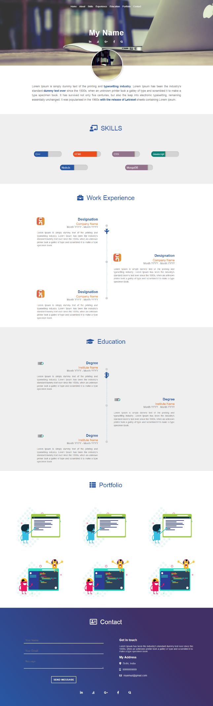

After '768px' breakpoint, it looks like –

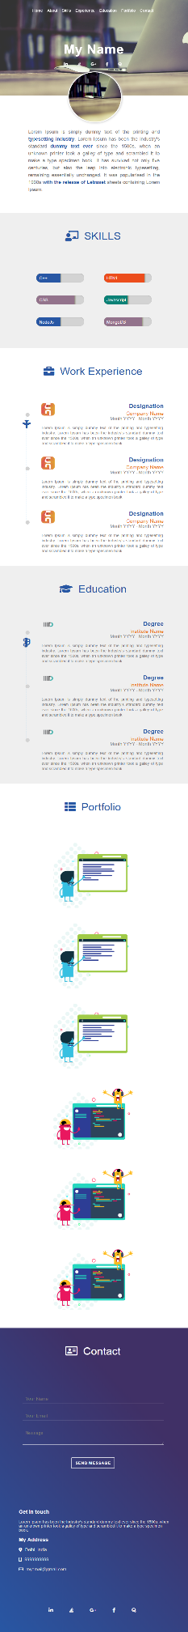
Again after '572px' breakpoint, it looks like -

Dropdown menu should appear on hover -
